Git Hands on Learning 04

Created new branch as “GitWork”
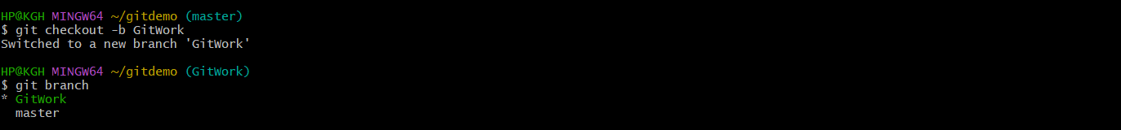
Created hello.xml in branch
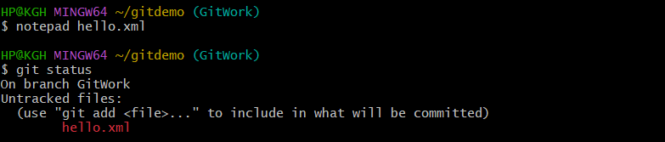
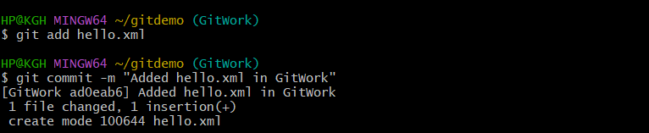

Switched back to master and created hello.xml in master branch


Merge conflict (git merge GitWork)
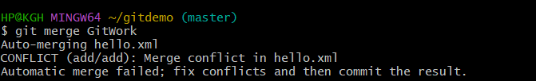
Resolved
